**Q1. Convert this UML class diagram to java code and test the java code.**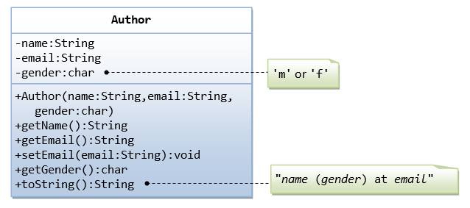

Solution:

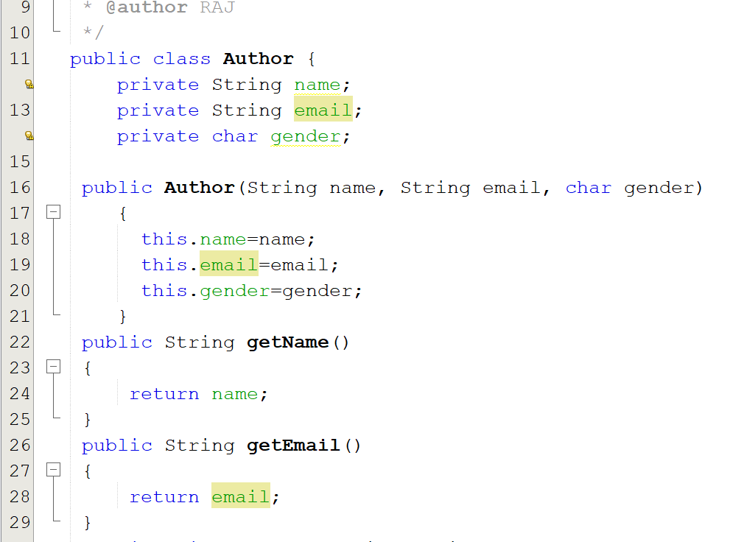

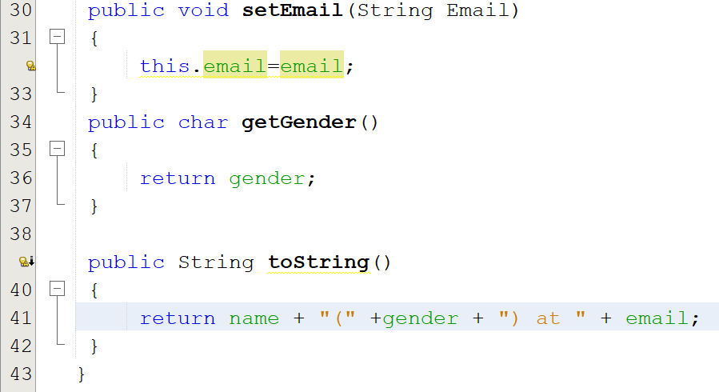

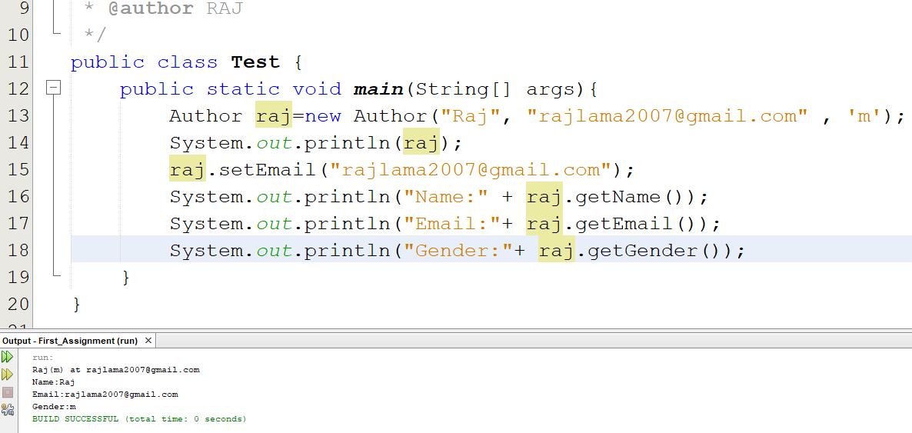

**Q2. Convert this UML class diagram to java code and test the java code.**

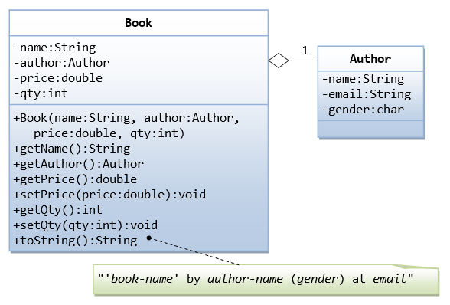

Solution:

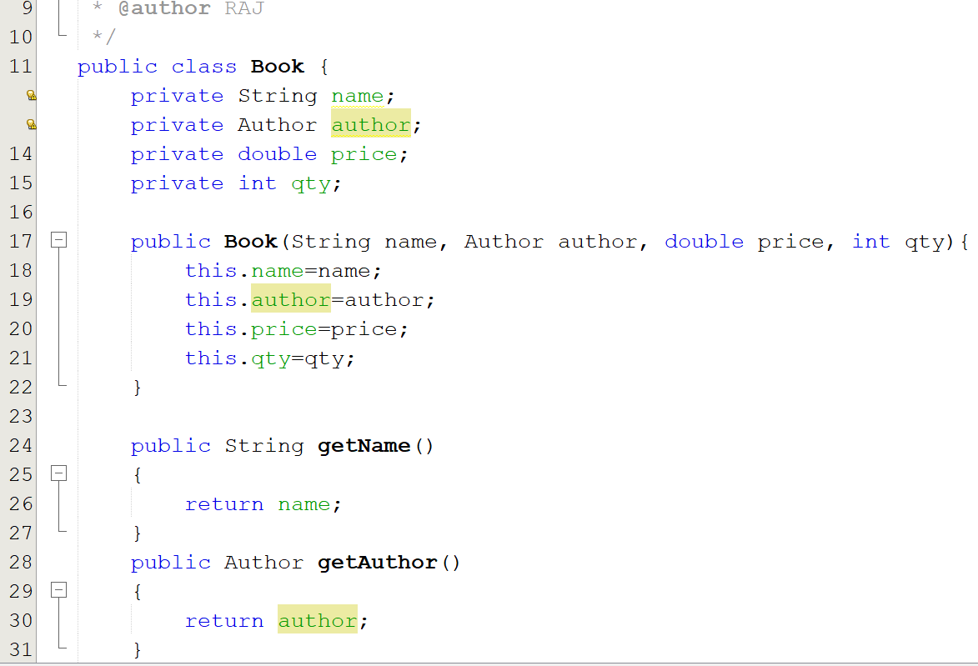

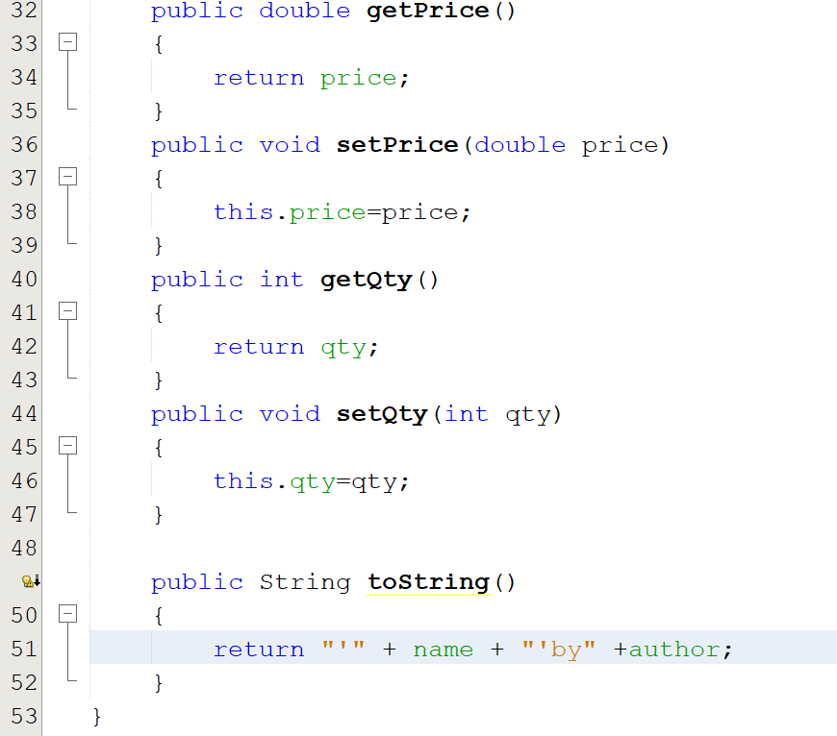

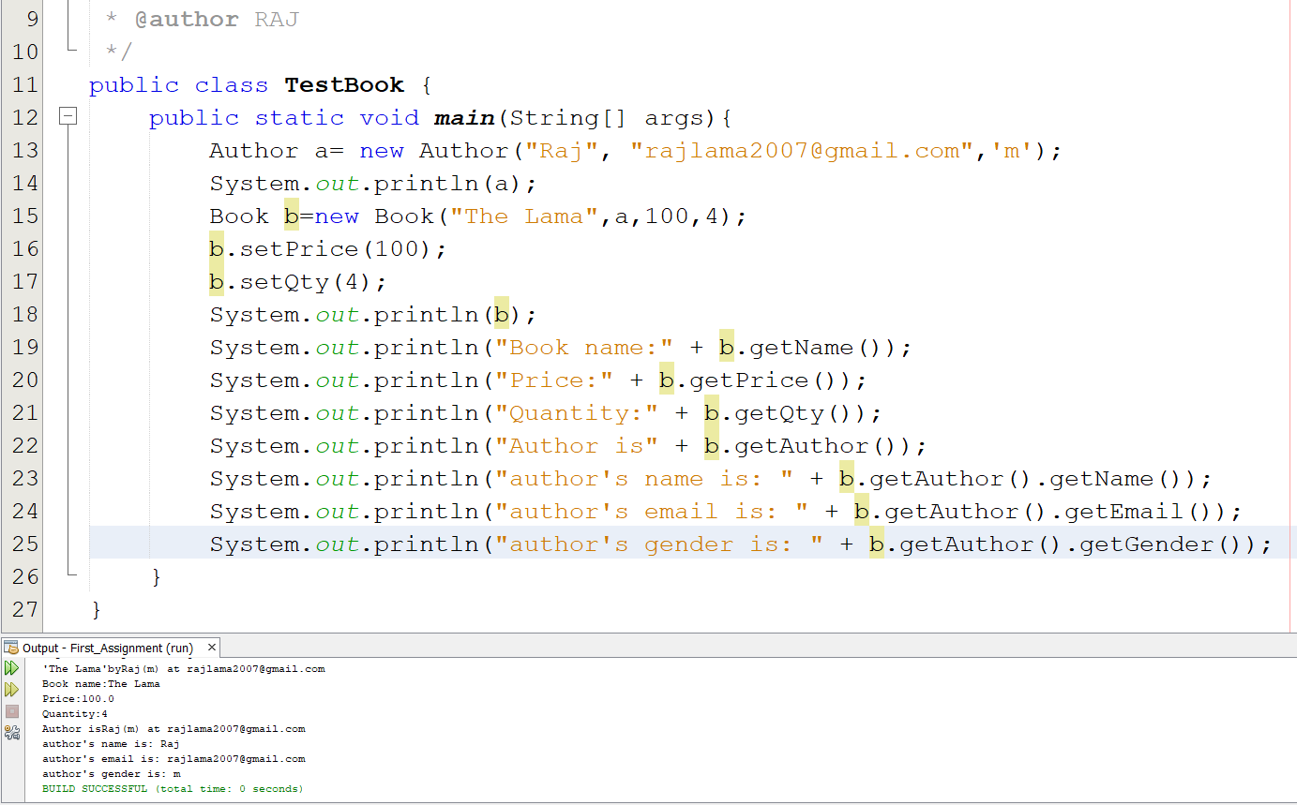

**Q3. Using inheritance convert the following UML class diagram to java code and test the java code.**

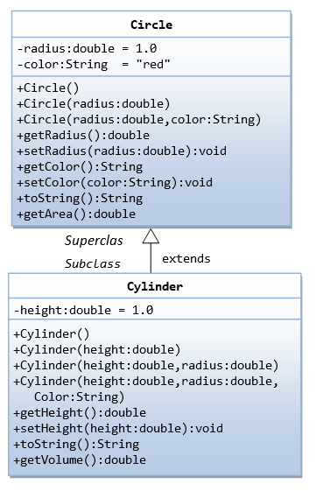

Solution:

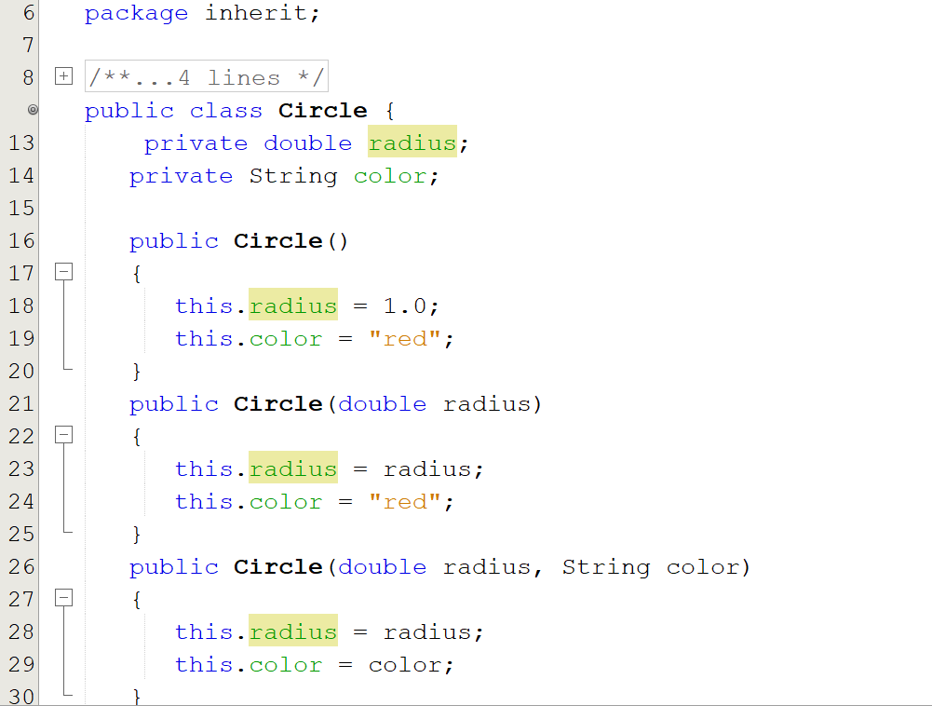

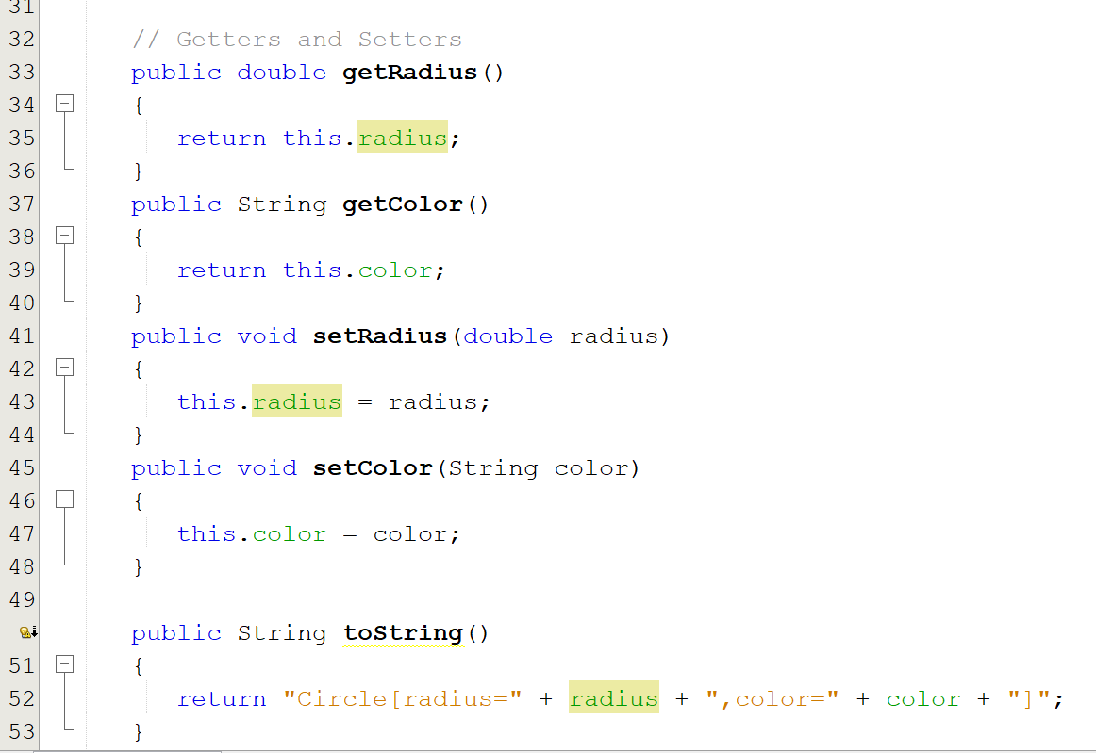

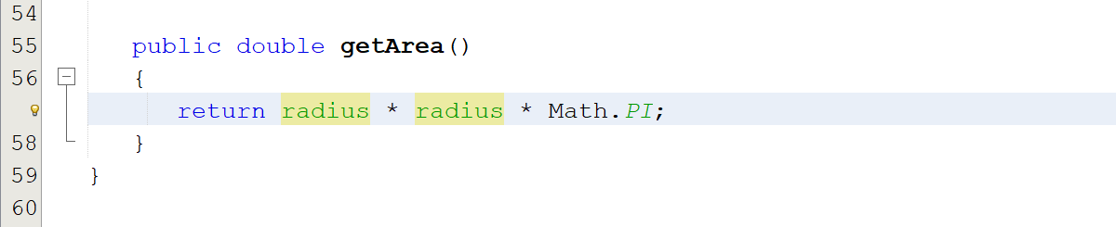

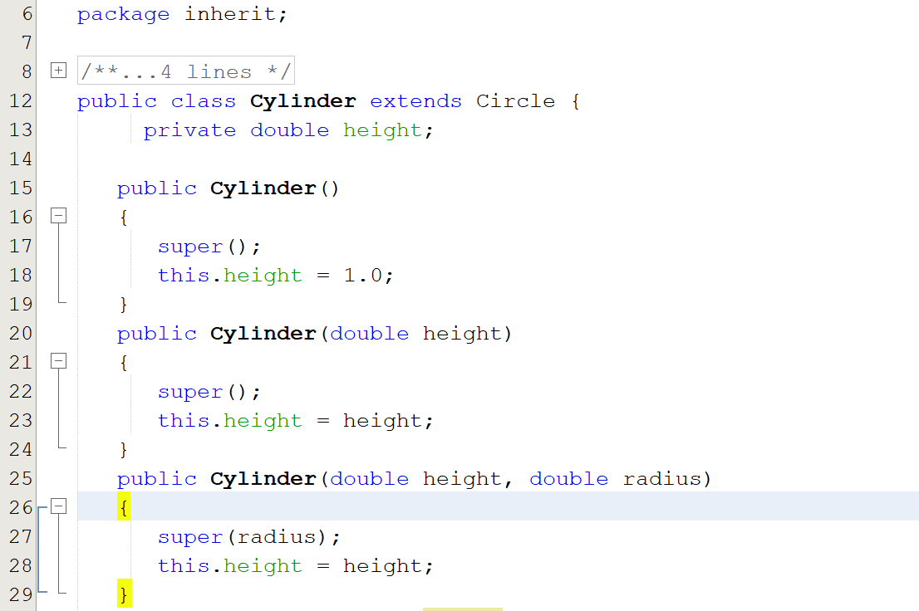

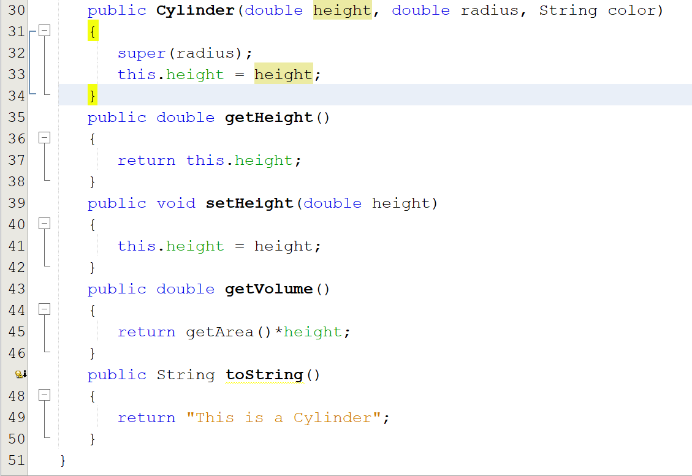

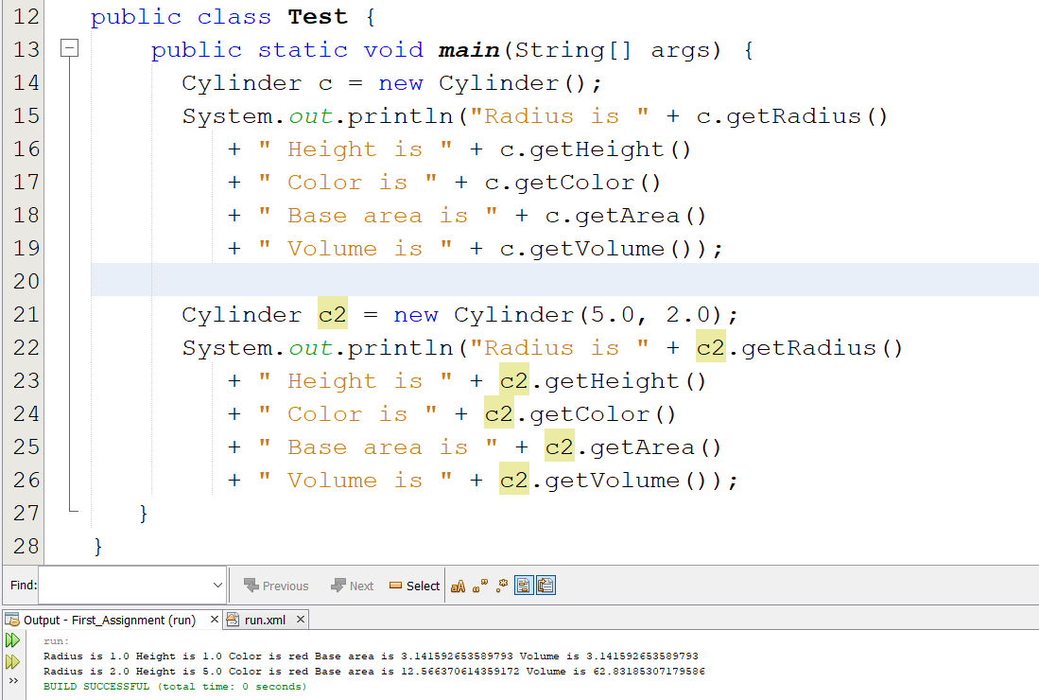

**Q4. What is encapsulation and advantages of encapsulation? Explain with an example.**

Encapsulation is a process of wrapping data and code together into a single unit. For example, a capsule which is mixed of several medicines.

The advantages of encapsulation:

1. It helps programmer in data hiding: hide the inner classes and give access to specific user to the desired codes which improves security.
2. Encapsulate class is easy for testing.
3. It allows the user to a programmer to use the program again and again which increases reusability.
4. It allows to make the data as read-only or write-only as we require it to be.

Example:

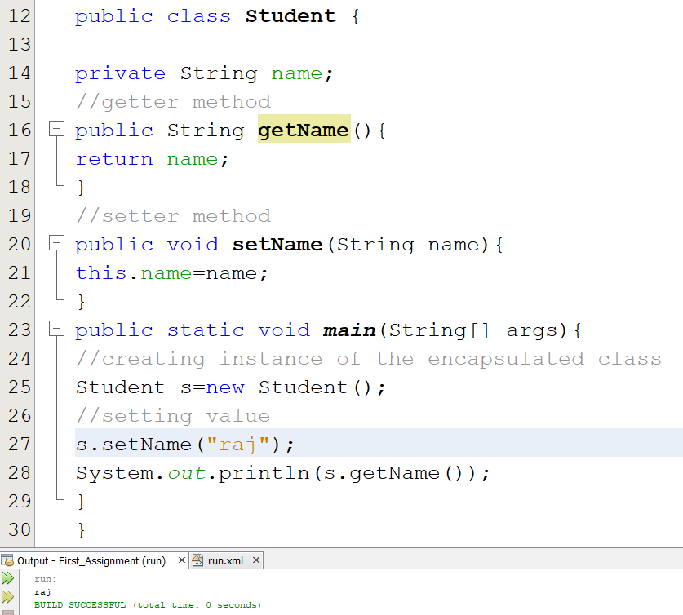

**Q5. What is abstract method in java? Explain with an example.**

Abstract method is a method which does not have implementation and that is declared as abstract in an abstract class in java.

Example:

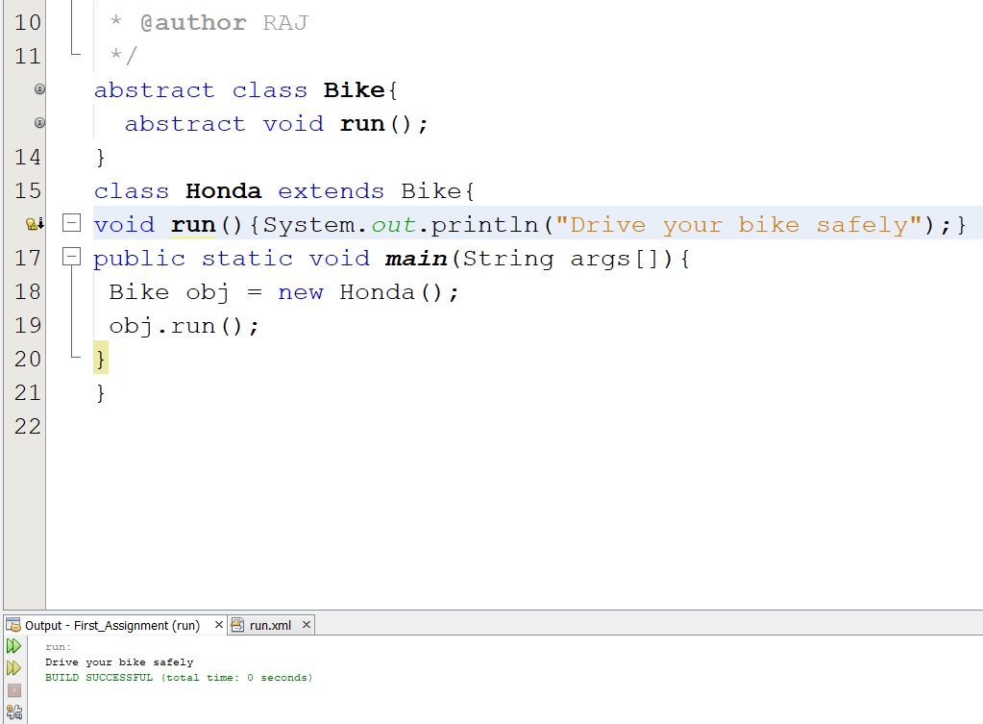

**Q6. What is an interface in java? Explain with an example.**

An interface is a blueprint of a class which contains collection of abstract methods that helps to achieve abstraction and multiple inheritance in java.

Example:

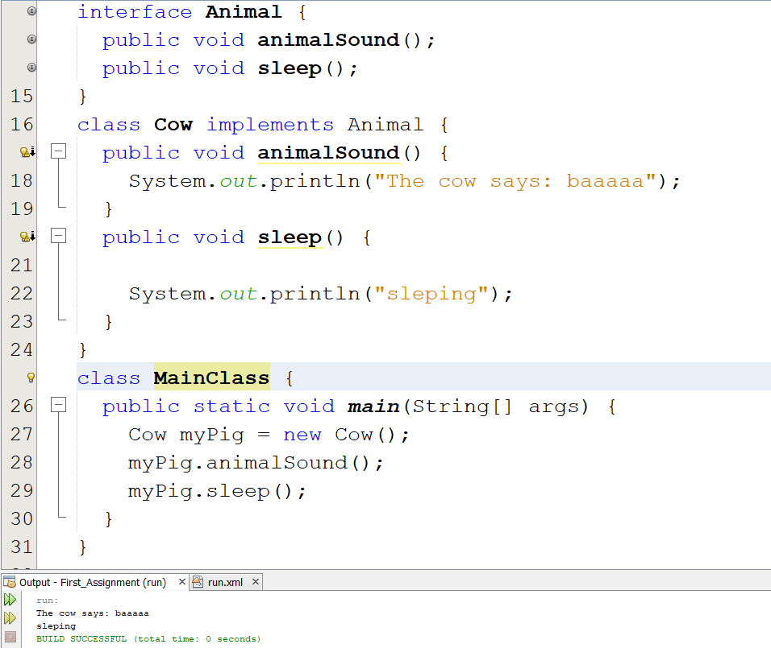

**Q7. Write a Java program to find the maximum and minimum value of an array.**

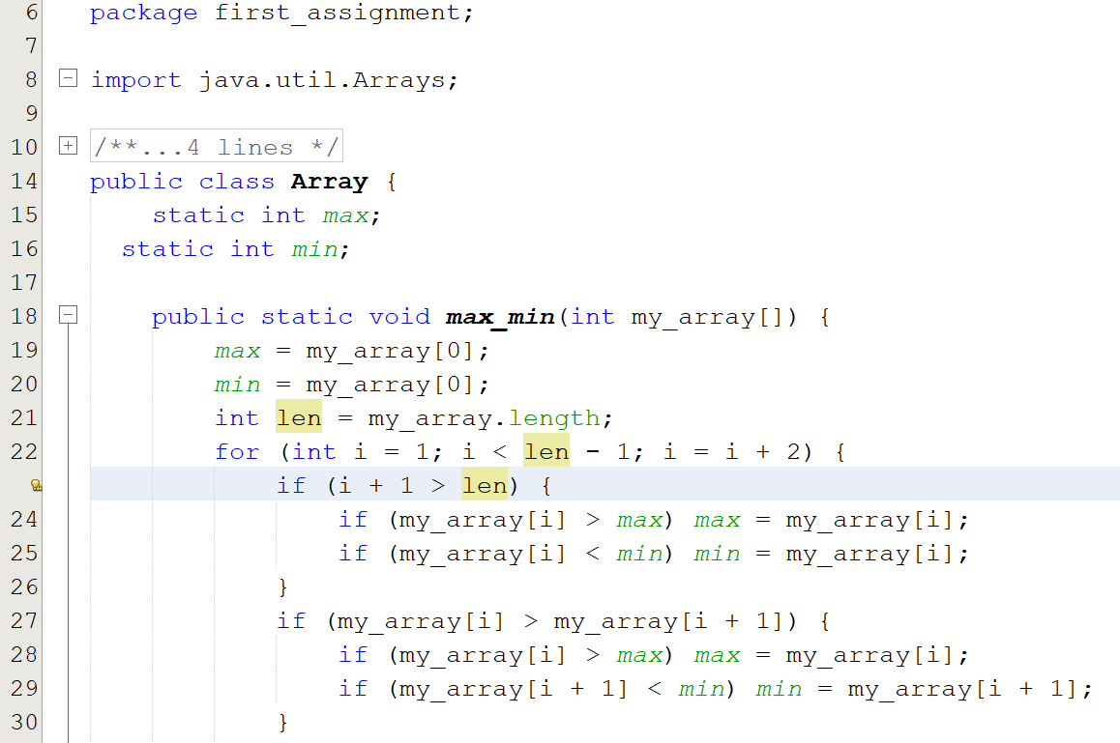

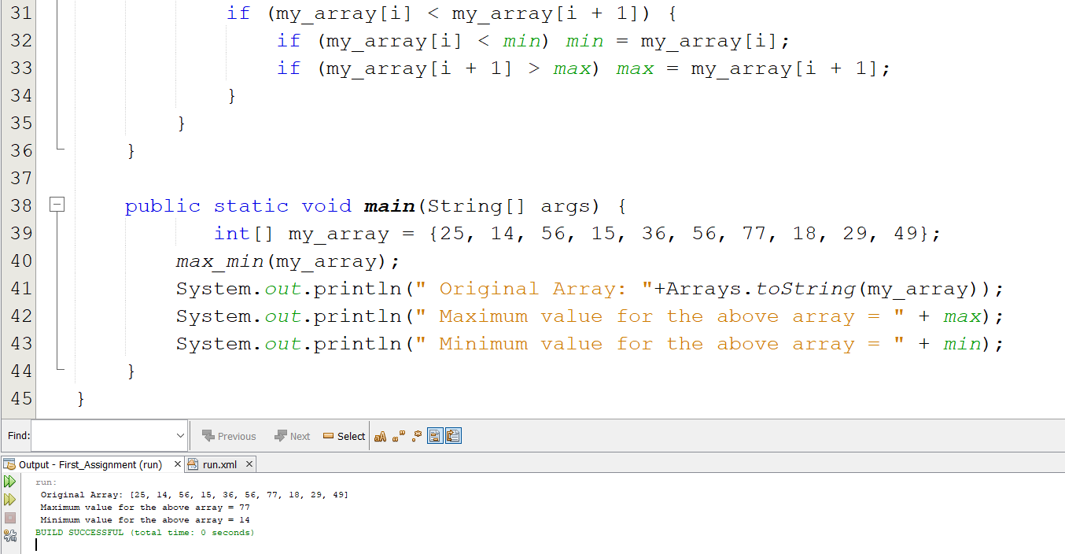

**Q8. Write a Java program to reverse an array of integer values.**

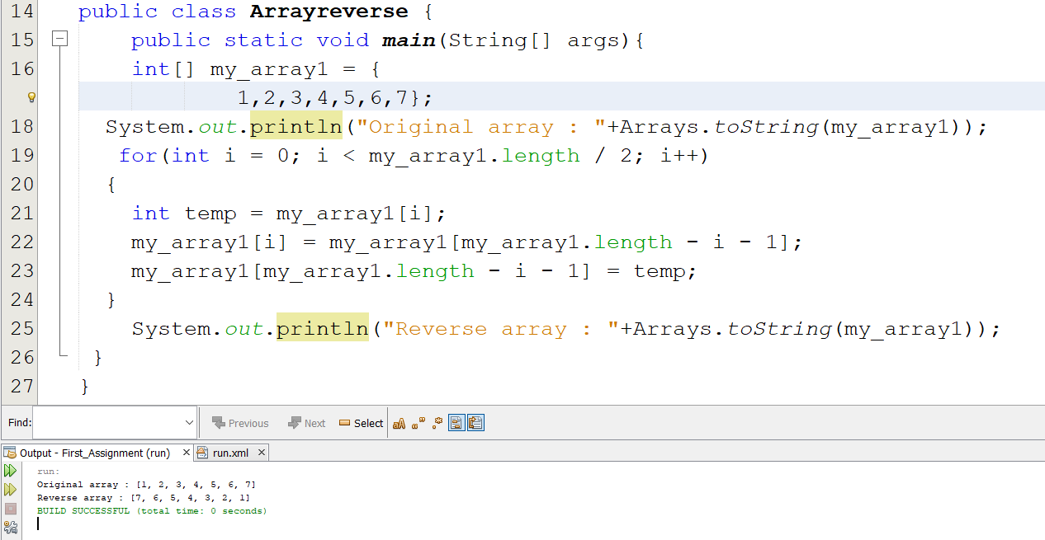

**Q9. Write a Java program to find the second largest element in an array.**

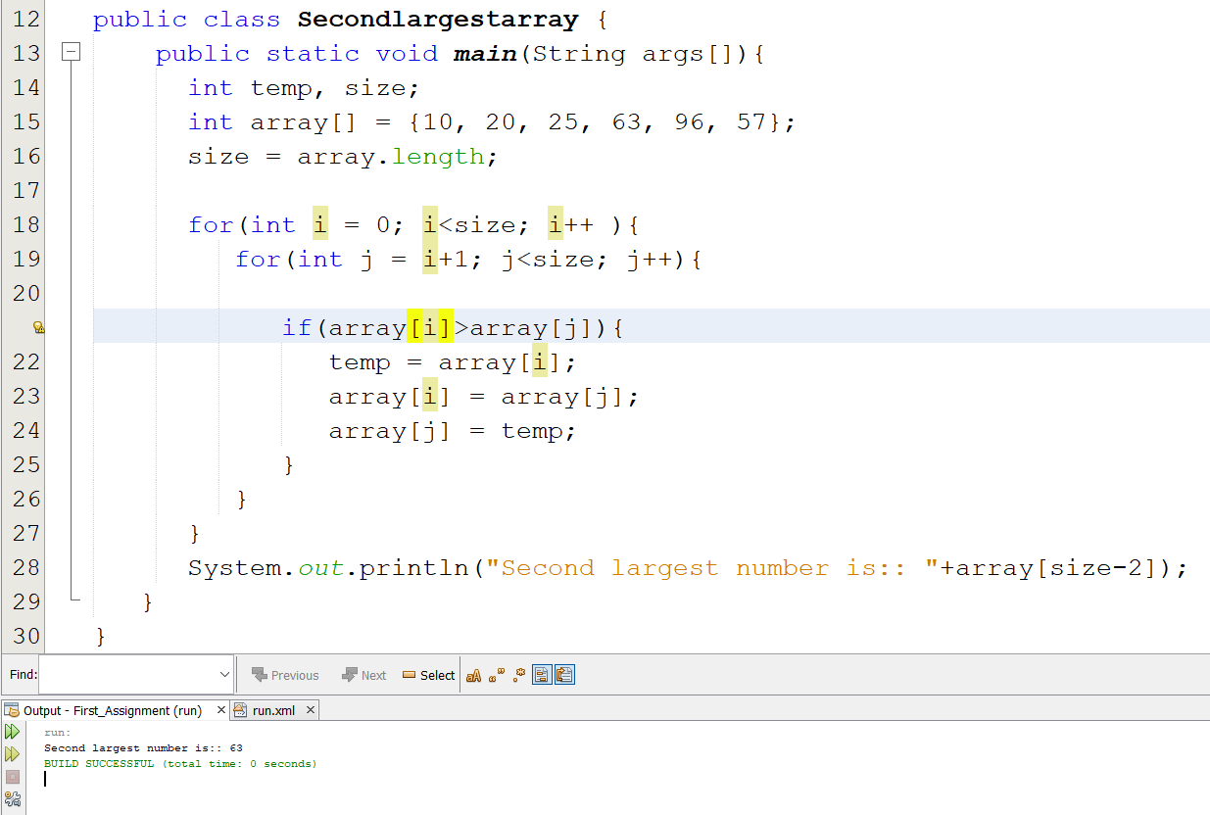

**Q10. What is an ArrayList in java? Explain with an example.**

An ArrayList is a resizable array, also called a dynamic array which can be found in the java.util package that grows its size to accommodate new elements and shrinks the size when the elements are removed.

Example:

